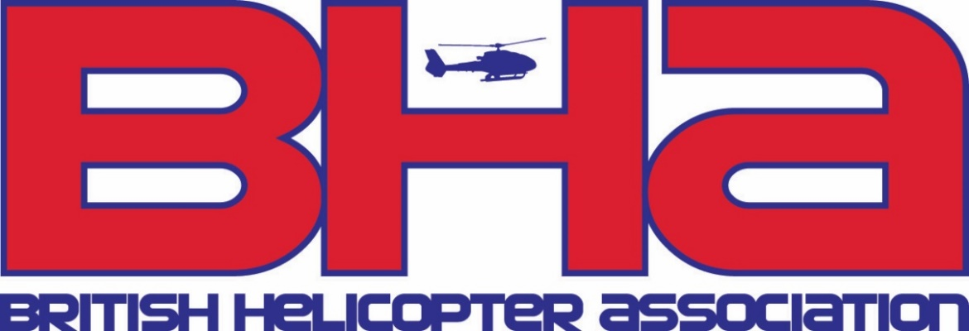

**BHA Handbook Order Form**

|  |  |
| --- | --- |
| Name: |  |
|  |
| Position: |  |
|  |
| Company: |  |
|  |
| Address: |  |
| Email: |  |

The 2023/2024 Handbook is priced at **£30.00** (inclusive of postage and packing) to any UK address.

Preferred payment by Bacs to the British Helicopter Association Ltd

**Sort code – 20-97-58 Account – 10197920**

Cheques should be made payable to The British Helicopter Association, please print and send this order form together with your full payment to:

**BHA**

**Unit C2, West Entrance**

**Fairoaks Airport**

**Chobham**

**Surrey GU24 8HU**

Queries can be addressed to info@britishhelicopterassociation.org or telephone +44(0)1276 856100